
CROWNFIELD EYE HOSPITAL DATABASE DEVELOPMENT REPORT
Individual Coursework Report for CPU4:103 Database Development


Student & Module Details
Detail | Information
Student Name | Iulian-Constantin Fodor
Module Code & Title | CPU4:103 Database Development
Assessment Title | Collaborative database build with individual report
Database Environment | MySQL 8.0 prototype using synthetic records
Submission Date | 9 November 2026
GitHub Repository (SQL Code) | [https://github.com/your-username/crownfield-database-cpu4103](https://github.com/your-username/crownfield-database-cpu4103) (Update with your URL)

Table of Contents
Student & Module Details 0
Table of Figures 2
1 Introduction 2
2 Analysis and Design 3
3 Implementation and Testing 4
4 Individual SQL 6
Query 1 Aggregate appointments by clinic 6
Query 3 Left join for patients without appointments 9
Query 4 CTE for priority follow up work 10
Query 6 Trigger for appointment time 12
5 Security and Transactions 13
6 Evaluation and Reflection 17
References 18

Table of Figures
Figure 1 Crow's Foot entity relationship diagram for the implemented schema 3
Figure 2 Successful schema execution in MySQL Workbench Full screen 5
Figure 3 Record count test for the main tables Full screen 5
Figure 4 Query 1 Aggregate appointments by clinic execution evidence Full screen 7
Figure 5 Query 2 Prescription inner join execution evidence Full screen 8
Figure 6 Query 3 Left join for patients without appointments execution evidence Full screen 9
Figure 7 Query 4 CTE for priority follow up work execution evidence Full screen 10
Figure 8 Query 5 Stored procedure with a clinician parameter execution evidence Full screen 11
Figure 9 Query 6 Trigger for appointment time execution evidence Full screen 12
Figure 10 Doctor role grants in MySQL Workbench Full screen 14
Figure 11. Hashing and encryption demonstration Full screen 15
Figure 12 Controlled update and rollback evidence Full screen 15
Figure 13 Controlled delete and rollback evidence Full screen 16

1 Introduction
The Crownfield case started as one large hospital record containing patient, visit, diagnosis, follow-up and prescription details. My report explains how I divided that record into related tables and how I checked the result with my own SQL examples. I focused on keeping the meaning of the data clear, especially where a visit can have more than one diagnosis or medicine. The implementation uses MySQL 8.0 and fictional records, so it demonstrates database development without representing a real clinical system.
My individual contribution was mainly the logical design and the explanation of the SQL features. I reviewed the stages from UNF to 3NF, checked the cardinalities, and worked through the prescription header and item structure. For my individual evidence I wrote a clinic aggregate, a prescription joins, a missing appointment query, a CTE, a clinician schedule procedure and an appointment-time trigger. I also checked that the sample data returns visible results for each example.

2 Analysis and Design
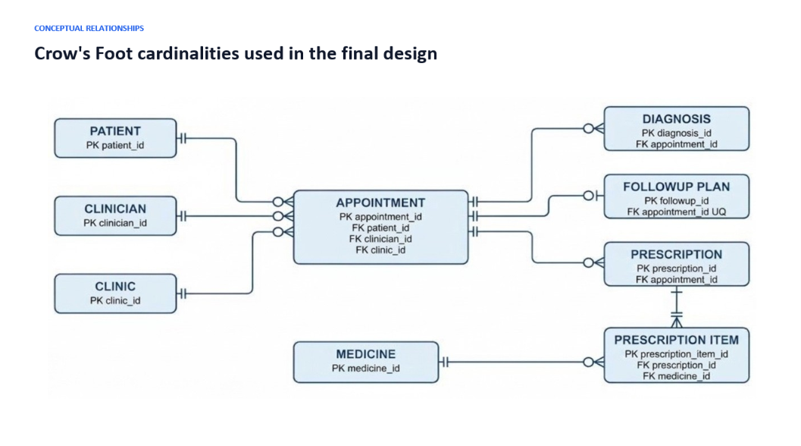
A wide record is difficult to maintain because several different subjects are mixed. Patient and clinic details repeat whenever another appointment is added, while medicine details repeat within the same visit. Changing one copy does not automatically correct the others. It is also awkward to add a clinician before the first
Figure 1 Crow's Foot entity relationship diagram for the implemented schema

insertion, update and deletion anomalies gave me the reason for the decomposition. This is the redundancy problem described by the relational model (Codd, 1970).I assumed that an appointment records one patient, one clinician and one clinic. Diagnosis and prescription are optional and may occur more than once for the same appointment. A follow-up plan is also optional, but the current design allows no more than one for each visit. A prescription can contain several medicines, which means the item table needs its own key and a foreign key to both prescription and medicine. I used these rules when checking the Crow's Foot labels.
The first change was to remove repeating medicine fields and give every cell one value, producing 1NF. For 2NF, attributes such as dose, route, frequency and duration were placed with the full prescription-item record. For 3NF, names and locations were moved to patient, clinician, clinic and medicine tables so they did not depend indirectly on an appointment. This gives each non-key attribute one proper owner and follows the normalisation steps in Connolly and Begg (2015).
The main design decision I worked on was separating prescription details. A prescription is a header linked to an appointment, while prescription_item holds each medicine and its dose, route, frequency and duration. This removes the repeating medicines from an appointment row and allows one prescription to contain several medicines without adding extra columns.
Stage | Change made | Reason
UNF | Wide visit record with repeating medicines | Shows the original anomalies
1NF | One value in each field and repeating items split | Removes repeating groups
2NF | Line-item facts depend on the complete item key | Removes partial dependency
3NF | Patient, clinician, clinic and medicine stored separately | Removes transitive dependency

3 Implementation and Testing
The physical model has eleven tables. I used primary keys for identity and foreign keys for every main relationship. Patient references, clinic names and clinician names have UNIQUE rules, and the appointment slot prevents the same clinician being booked twice at one date and time. Required values use NOT NULL, while statuses and priorities use controlled choices and defaults. Parent deletions are restricted when appointments depend on them, and dependent rows can cascade. MySQL documents this as referential integrity (Oracle, 2026a).
I ran the schema before the data and checked the table totals afterwards. The main tables met the required sample size, including 12 patients and appointments and 10 clinicians, clinics and medicines. The clinical detail held 11 diagnoses, 10 follow-up plans, 12 prescription headers and 20 items. I used transactions for the test appointment, status update and item deletion, then rolled the changes back. This let me inspect the result without changing the supplied dataset.
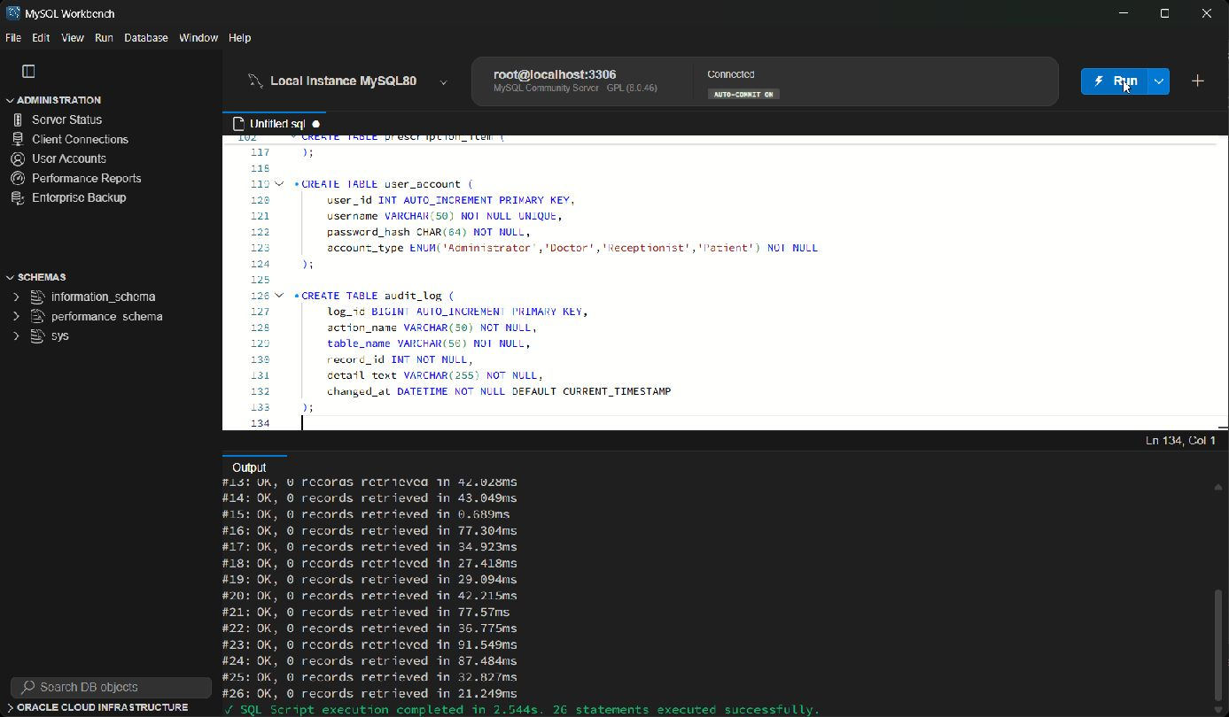
Figure 2 Successful schema execution in MySQL Workbench Full screen
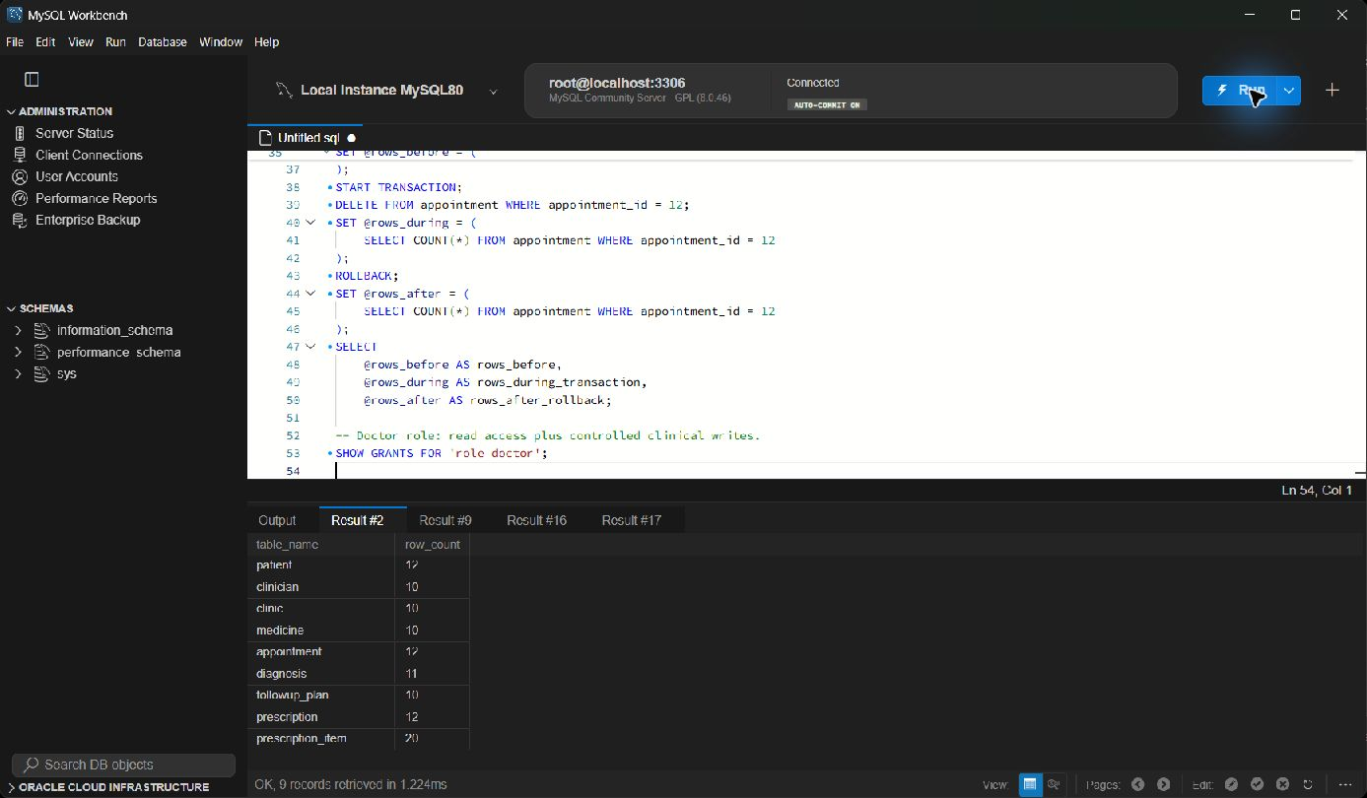
Figure 3 Record count test for the main tables Full screen
Test | Expected result | Observed result
Schema build | Tables and constraints created | Pass
Record counts | At least 10 rows in each main table | Pass
Valid follow-up | Future date accepted with Pending status | Pass
Controlled update | Change visible before rollback | Pass
Controlled delete | Delete visible before rollback | Pass

4 Individual SQL
I gave each SQL feature a question before writing it. My aggregate asks which clinics have two or more appointments. The INNER JOIN follows a prescription item to its medicine and patient through five tables. The LEFT JOIN finds a registered patient with no appointment, and the CTE lists High or Urgent follow-up work. The procedure filters a clinician schedule by name, while the trigger checks a scheduling rule.

Query 1 Aggregate appointments by clinic
Question answered Which clinics have at least two appointments
SELECT cl.clinic_name, cl.location, COUNT(a.appointment_id) AS appointment_count
FROM clinic cl JOIN appointment a ON a.clinic_id = cl.clinic_id
GROUP BY cl.clinic_id, cl.clinic_name, cl.location
HAVING COUNT(a.appointment_id) >= 2;
I grouped appointments by clinic and used HAVING after the grouping. City Road Clinic returned three appointments, which agrees with the sample rows for appointment 1, 2 and 4. Other clinics have one visit each, so they do not meet the condition. This shows the difference between filtering source rows and filtering a calculated group total.
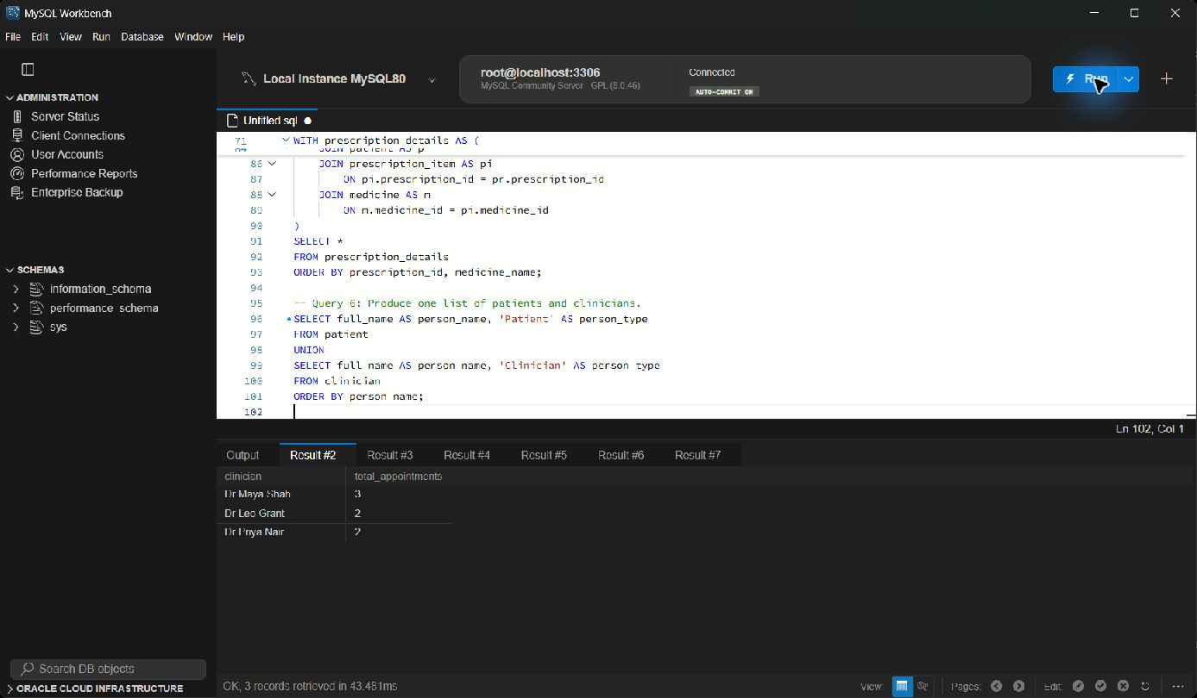
Figure 4 Query 1 Aggregate appointments by clinic execution evidence Full screen
Query 2 Prescription inner join
Question answered Which medicines were prescribed to each patient
SELECT pr.prescription_id, p.patient_ref, p.full_name, m.medicine_name,
pi.dose, pi.route, pi.frequency, pi.duration
FROM prescription_item pi JOIN prescription pr ON pr.prescription_id=pi.prescription_id
JOIN appointment a ON a.appointment_id=pr.appointment_id
JOIN patient p ON p.patient_id=a.patient_id
JOIN medicine m ON m.medicine_id=pi.medicine_id;
This query starts with the prescription item and follows the foreign keys through prescription and appointment to patient, then joins medicine for its readable name. The result contains 20 item rows, matching the sample data. The path demonstrates why the design does not store a patient_id directly in prescription_item and still retrieves the patient correctly.
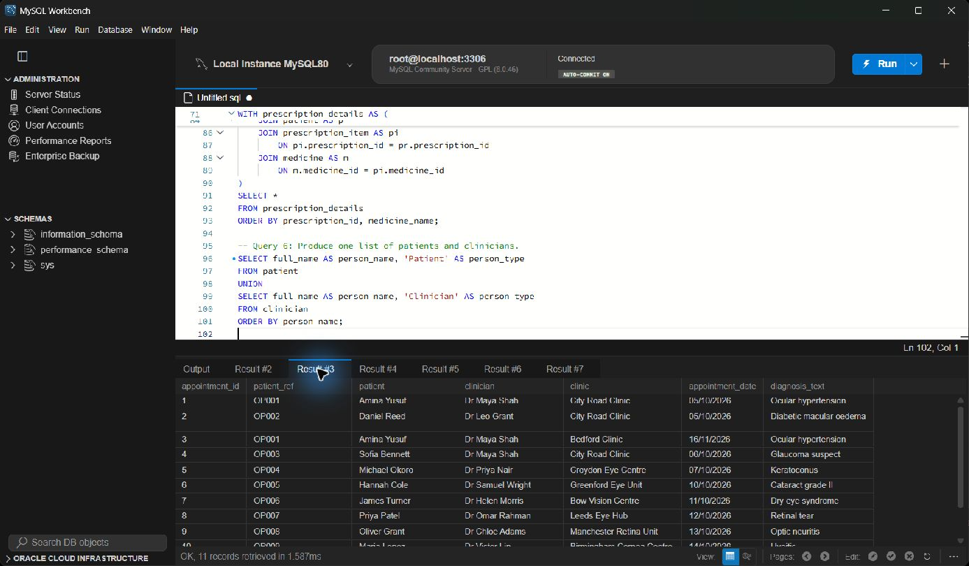
Figure 5 Query 2 Prescription inner join execution evidence Full screen

Query 3 Left join for patients without appointments
Question answered Which registered patients have not been booked
SELECT p.patient_ref, p.full_name, p.postcode
FROM patient p LEFT JOIN appointment a ON a.patient_id=p.patient_id
WHERE a.appointment_id IS NULL;
The LEFT JOIN keeps every patient and supplies NULL appointment columns where no booking exists. Filtering on the NULL key returned OP012, Noah Evans. An INNER JOIN would remove that patient from the result. This feature is useful for finding registered people who have not entered the appointment workflow.
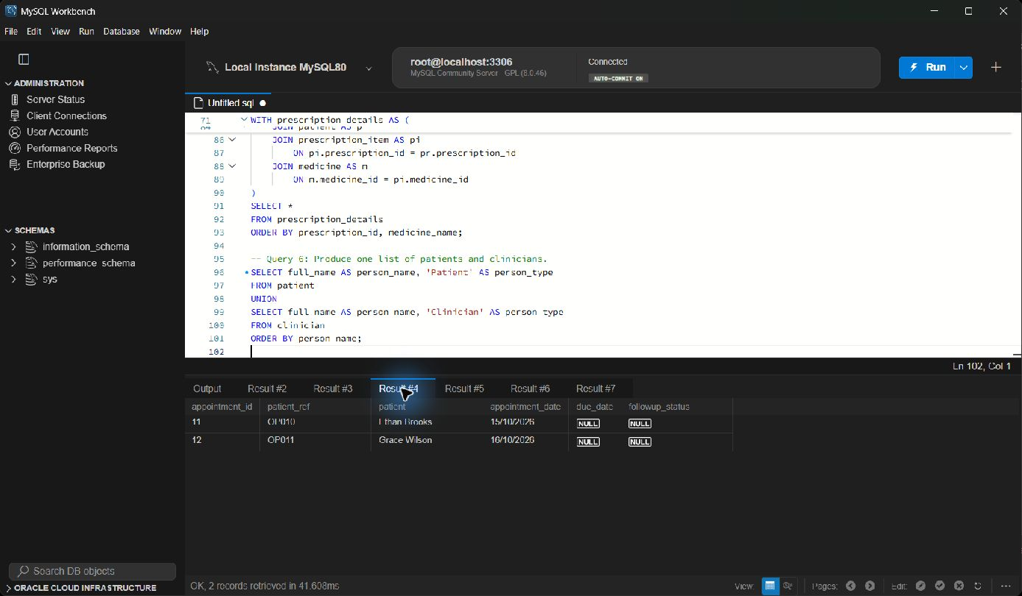
Figure 6 Query 3 Left join for patients without appointments execution evidence Full screen

Query 4 CTE for priority follow up work
Question answered Which pending follow ups are High or Urgent priority
WITH priority_followups AS (
SELECT p.patient_ref, p.full_name, f.due_date, f.priority, c.full_name AS clinician
FROM followup_plan f JOIN appointment a ON a.appointment_id=f.appointment_id
JOIN patient p ON p.patient_id=a.patient_id
JOIN clinician c ON c.clinician_id=a.clinician_id WHERE f.status='Pending'
) SELECT * FROM priority_followups WHERE priority IN ('High','Urgent');
The CTE first creates a readable set of pending follow-up work with patient and clinician names. The outer query then keeps only High or Urgent rows. The result includes the High plan for OP001 and the Urgent plans for OP002 and OP008. Separating the steps made the purpose easier to explain than repeating the joins inside another expression.
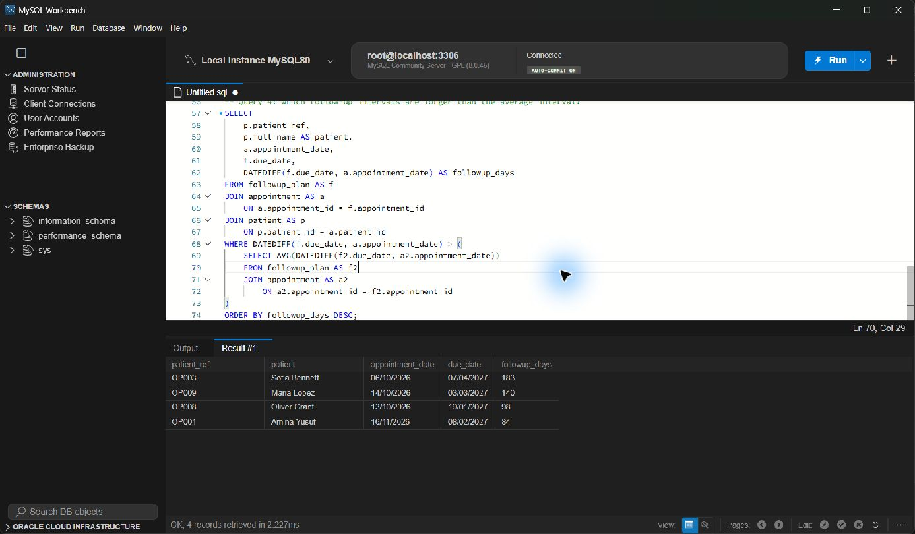
Figure 7 Query 4 CTE for priority follow up work execution evidence Full screen

Query 5 Stored procedure with a clinician parameter
Question answered What appointments are assigned to one clinician
CREATE PROCEDURE fodor_clinician_schedule(IN p_clinician_name VARCHAR(100))
BEGIN
SELECT ... FROM clinician c JOIN appointment a ON a.clinician_id=c.clinician_id ...
WHERE c.full_name = p_clinician_name;
END;
CALL fodor_clinician_schedule('Dr Maya Shah');
The procedure takes a clinician name and returns the matching date, time, patient, clinic and status. The call for Dr Maya Shah returned five appointments in date order. The input parameter makes the same feature reusable for another clinician and keeps the filtering rule in one tested database object.
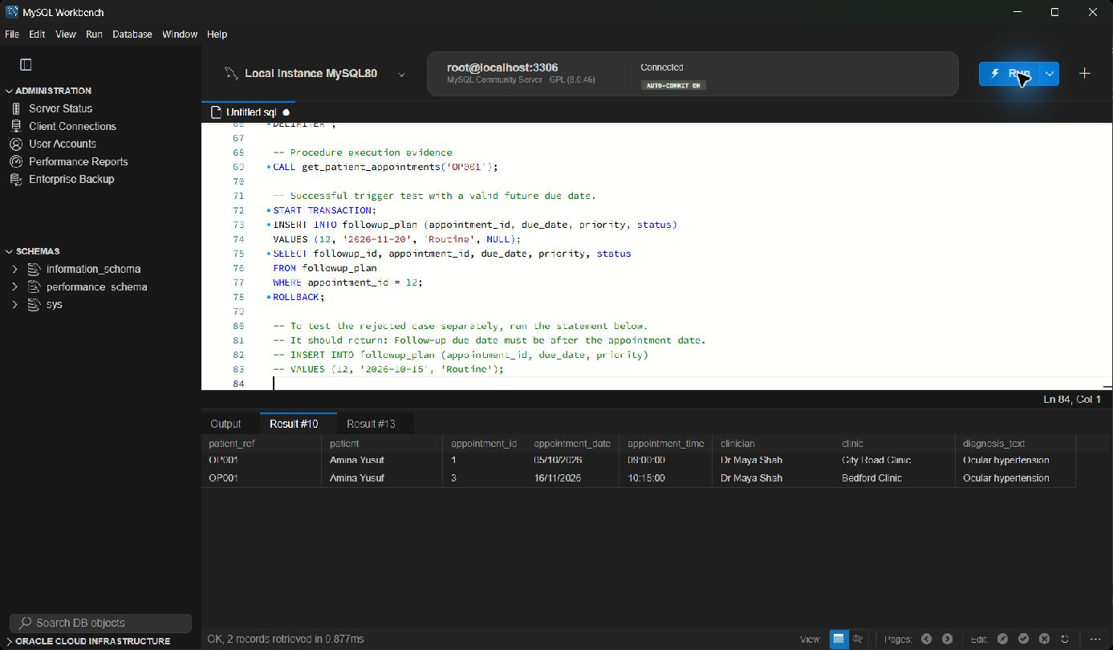
Figure 8 Query 5 Stored procedure with a clinician parameter execution evidence Full screen

Query 6 Trigger for appointment time
Question answered How does the database reject an appointment outside working hours
CREATE TRIGGER trg_fodor_appointment_time BEFORE INSERT ON appointment
FOR EACH ROW BEGIN
IF NEW.appointment_time < '08:00:00' OR NEW.appointment_time > '18:00:00' THEN
SIGNAL SQLSTATE '45000' SET MESSAGE_TEXT =
'Appointment time must be between 08:00 and 18:00';
END IF;
END;
The trigger checks the time before the row is inserted. A 10:00 appointment for patient OP012 was accepted inside a transaction, while the separate 07:30 test raises the message defined in the trigger. I rolled the valid insert back so the sample count remained unchanged. This rule is deliberately simple but shows that validation can be enforced in the database.
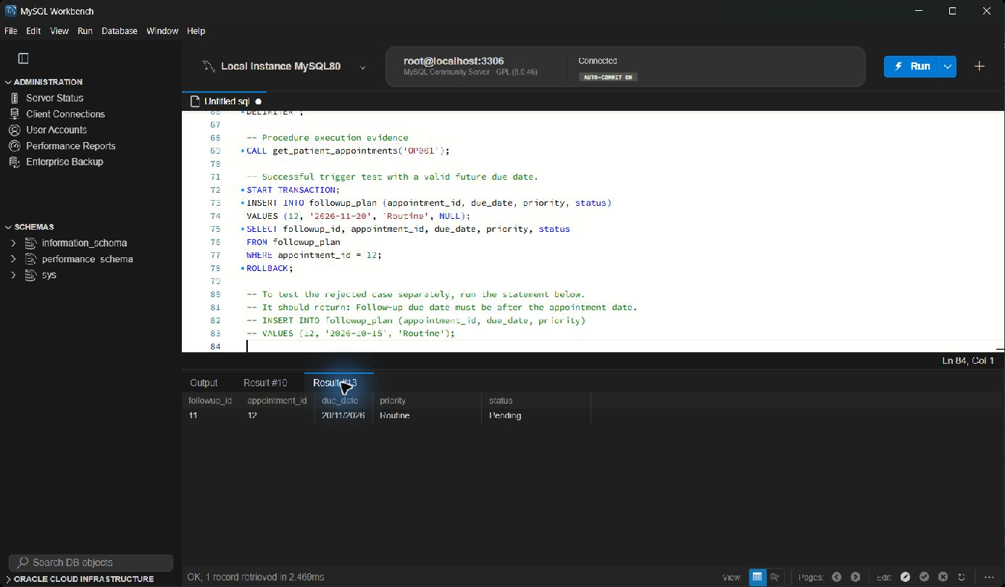
Figure 9 Query 6 Trigger for appointment time execution evidence Full screen

5 Security and Transactions
The access model contains administrator, doctor, receptionist and patient roles. Administration stays inside the coursework database. Doctors can read records and update clinical tables, while receptionists can maintain patients and bookings. The patient example reads a restricted medicine view and cannot change the source tables. Roles are useful because MySQL can assign a named collection of privileges instead of repeating the same GRANT list for every user (Oracle, 2026b).
Role | Main permissions | Purpose
Administrator | Project database administration | Build and maintain the prototype
Doctor | SELECT plus clinical INSERT and UPDATE | Record diagnoses, follow-up and prescriptions
Receptionist | Patient and appointment maintenance | Manage bookings and demographics
Patient | Read-only demonstration access | Prevent direct data changes

I checked three data-protection examples. Passwords are represented by SHA-256 hashes, postcodes can be stored as AES encrypted bytes, and a prepared statement receives the medicine name as a bound value. OWASP Foundation (2026) recommends parameterised statements because the value is not treated as part of the SQL command. The example key and records are intentionally simple for the assessment. A real system would need managed keys, account expiry, monitoring and formal clinical access controls.
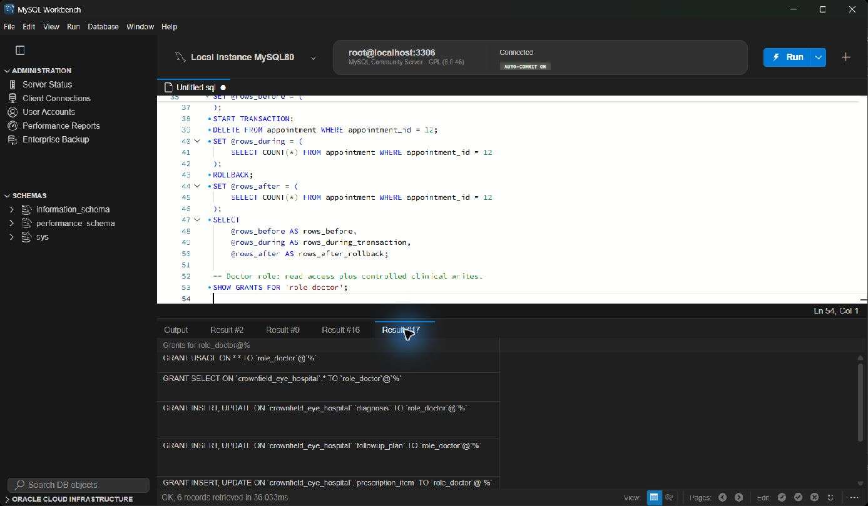
Figure 10 Doctor role grants in MySQL Workbench Full screen

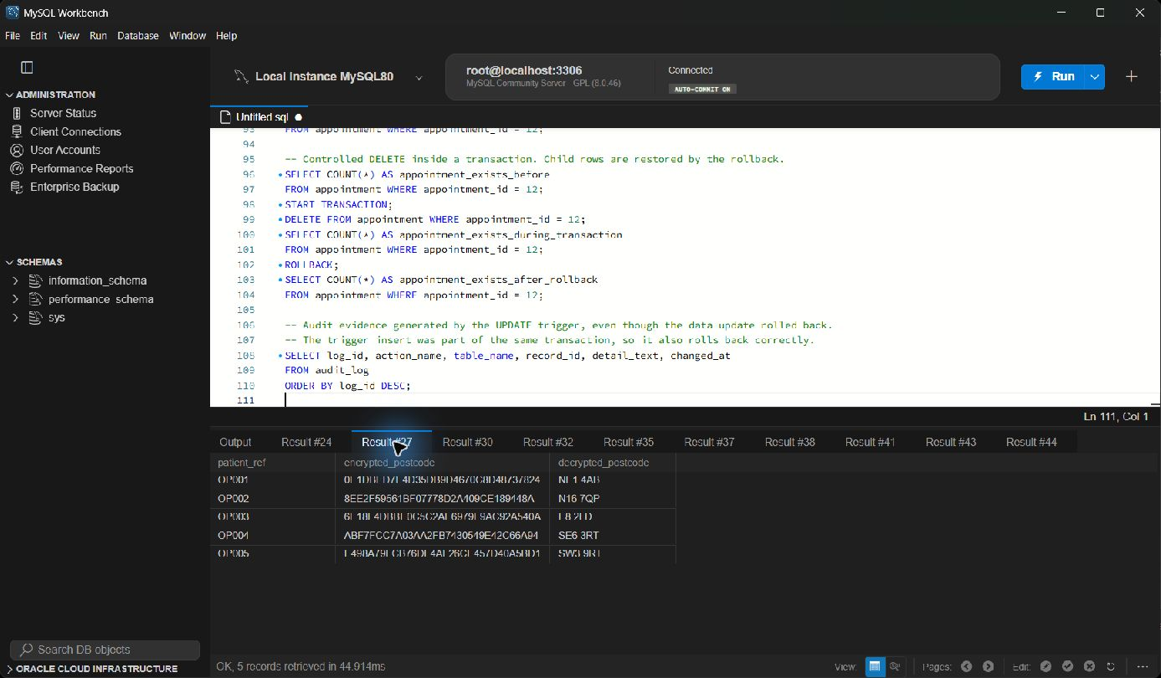
Figure 11. Hashing and encryption demonstration Full screen
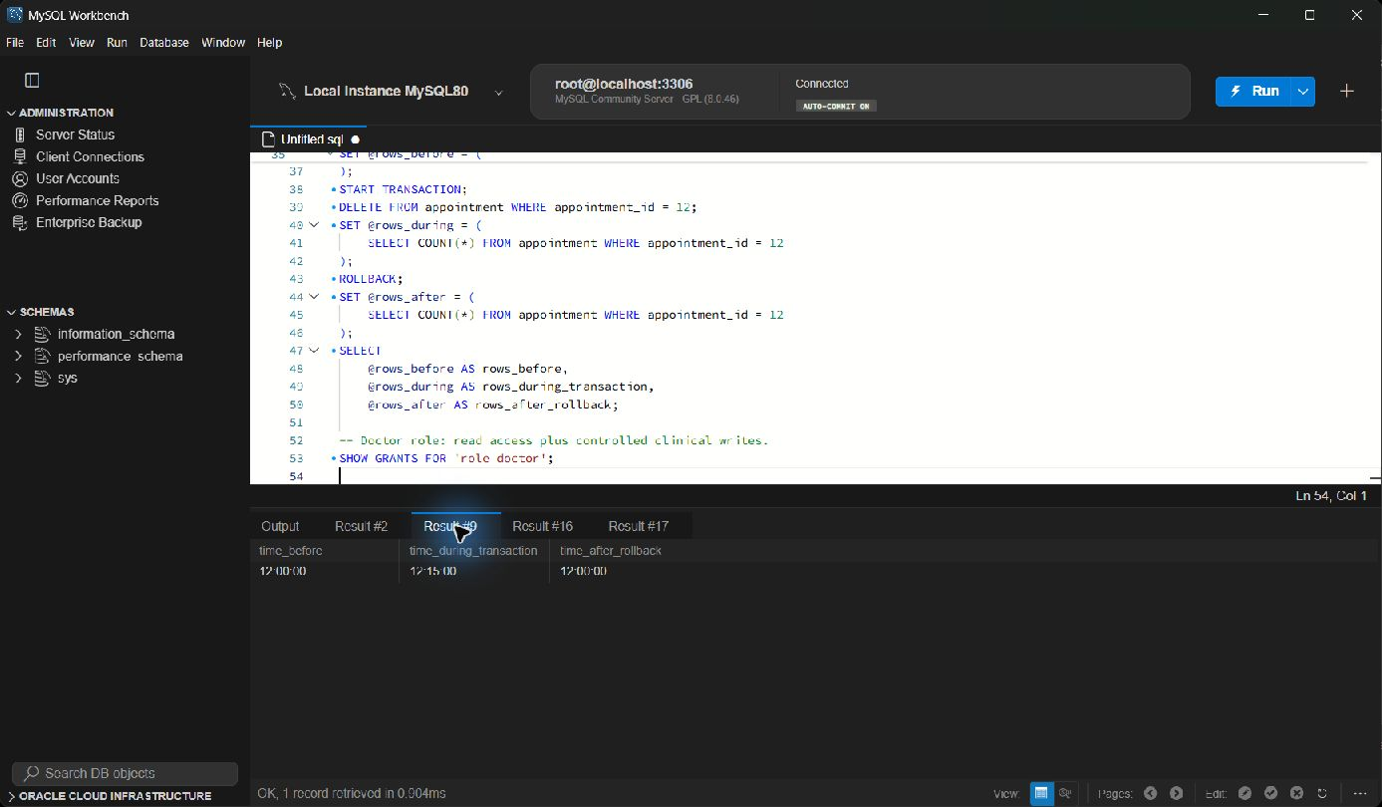

Figure 12 Controlled update and rollback evidence Full screen
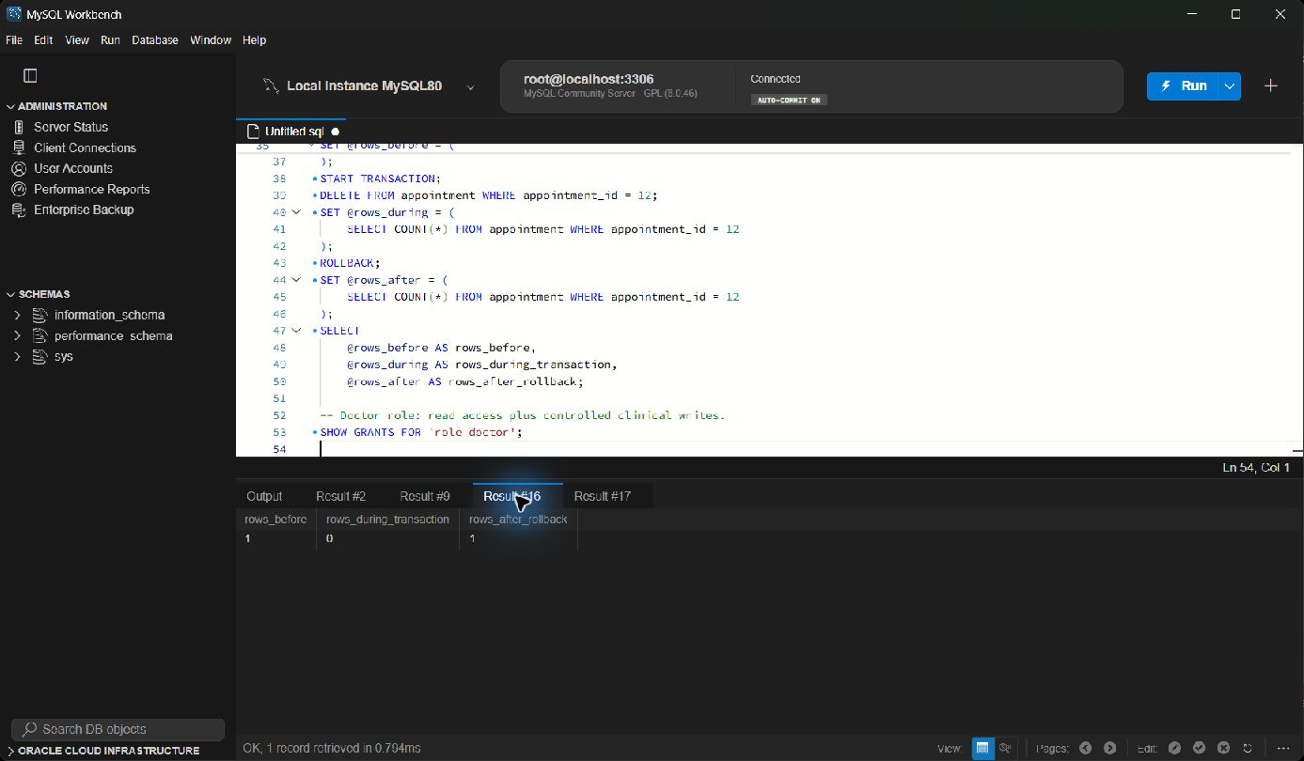
Figure 13 Controlled delete and rollback evidence Full screen

6 Evaluation and Reflection
The normalised model supports questions that were awkward in the original record. My clinic aggregate gives a short workload view, the prescription join shows exactly which item belongs to which patient, and the LEFT JOIN exposes a patient who has not been booked. The procedure can be called again for another clinician without rewriting its SELECT. The trigger rejects an appointment before 08:00 or after 18:00, giving the database a simple rule that is independent of an application form.
The main challenge in my part was turning the wide unnormalised record into tables without losing the meaning of optional clinical details. I solved it by keeping appointment as the central visit record, allowing many diagnoses and prescriptions, and keeping follow-up optional. This supported LO1 through the ER model and normalisation, LO2 through the six tested SQL features, and LO3 through the integrity constraints and trigger.
The most useful test was following a medicine back through prescription, appointment and patient. It proved why the item table needs both foreign keys and showed that I had not created a shortcut relationship. The patient-without-appointment result also confirmed that the LEFT JOIN works differently from an INNER JOIN. When checking the ER diagram I corrected the diagnosis side to zero or many, because the table contains no UNIQUE rule on appointment_id. That small label matters because it describes what the database permits.
The design is a teaching prototype and the records are synthetic. It does not cover every hospital workflow, attachment, consent record or clinical audit requirement. The ER model permits several diagnoses for one appointment, while the current data usually contains one. A production design would also need stronger identity management, backup planning and formal clinical governance.

References
Codd, E.F. (1970) 'A relational model of data for large shared data banks', Communications of the ACM, 13(6), pp. 377–387. doi: 10.1145/362384.362685.
Connolly, T. and Begg, C. (2015) Database Systems: A Practical Approach to Design, Implementation, and Management. 6th edn. Harlow: Pearson Education.
Oracle (2026a) MySQL 8.0 Reference Manual: Foreign Key Constraints. Available at: https://dev.mysql.com/doc/refman/8.0/en/constraint-foreign-key.html (Accessed: 3 November 2026).
Oracle (2026b) MySQL 8.0 Reference Manual: Using Roles. Available at: https://dev.mysql.com/doc/refman/8.0/en/roles.html (Accessed: 3 November 2026).
OWASP Foundation (2026) SQL Injection Prevention Cheat Sheet. Available at: https://cheatsheetseries.owasp.org/cheatsheets/SQL_Injection_Prevention_Cheat_Sheet.html (Accessed: 3 November 2026).

